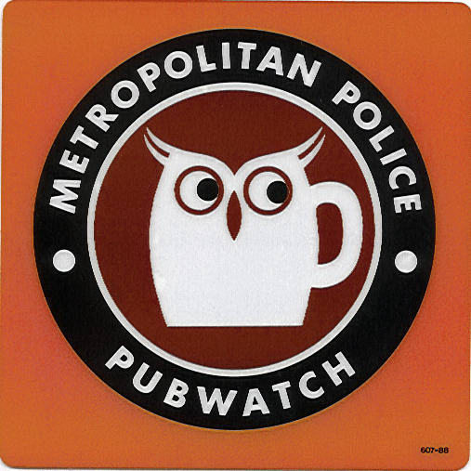
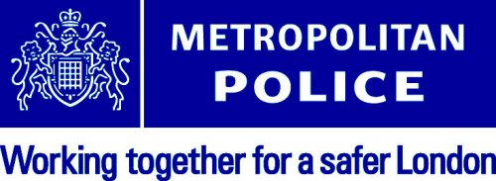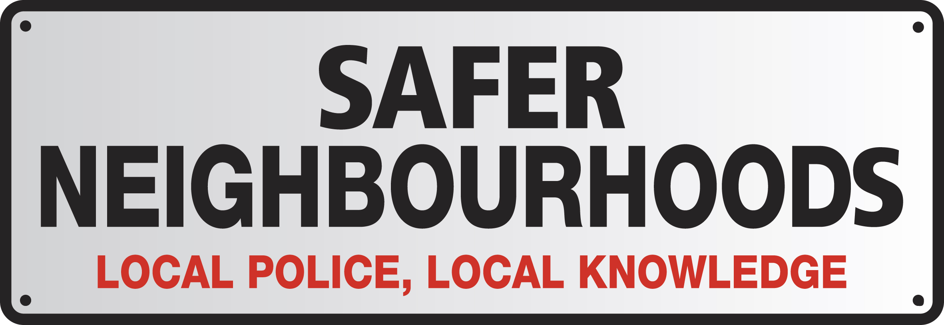

The Teddington Pubwatch &
Safer Neighbourhoods Team

Invite you to a



On

At

THE TEDDINGTON ARMS

(HIGH STREET, TEDDINGTON)

Commencing at:

Races to take place throughout the evening…
Raffle to be held with prizes donated
by local Shopwatch members
Many prizes to be won!!!

All money raised from the event will be donated to the following 4 local charities:



